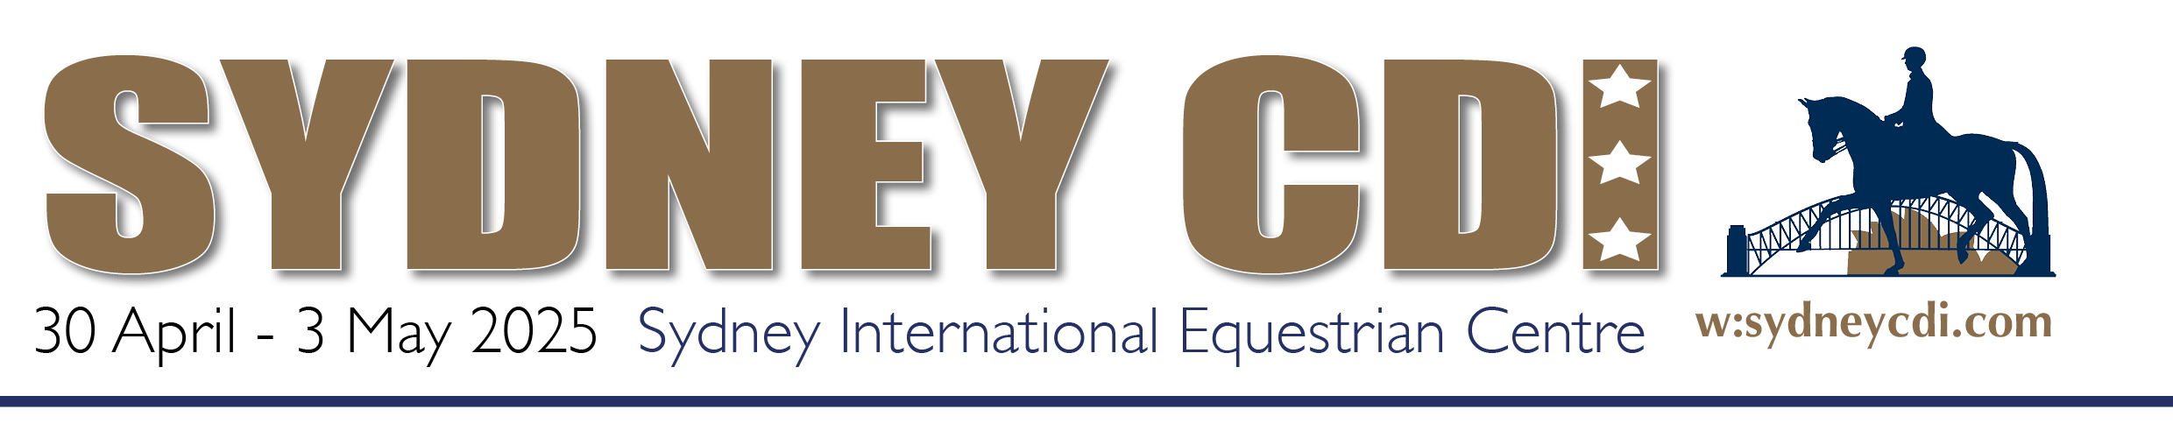

2025 Stallion Show - Application

Yes, I would love to be part of the Stallion Show & Silent Tender Fundraiser
at the 2025 Sydney CDI!
- Yes, I will be entering a Stallion in the Showcase on Saturday evening (from 6pm)
- My preferred music/song to be played during my stallion’s presentation is:
_______________________________________________________________________
- Yes, I would like to donate a Stallion Service to the Stallion Show Silent Tender fundraiser
- There will be a reserve on my donated service: YES / NO
If yes, the value of this reserve is: $___________
- Any additional conditions please note these here:

In addition:
- I would like any additional bids to be forwarded to me following close of tender:
YES / NO
- I would be happy to donate 10% of any additional bids I accept, back to the Sydney CDI and Dressage NSW: YES / NO
- My stallion won’t be on-site, and I would like to book stable/bedding and camping (booking details will be provided closer to the event): YES / NO

Conditions of participation:

- Participation in 2025 is FREE. Stallions not competing in the event will need to cover the cost of booking stables/bedding and camping.
- Information for programme booklet (refer requirements next page for details is required by 28 March 2025
- For safety reason, Stallions must be either stabled or confined in a truck or float when not under saddle.

The Sydney CDI agrees to provide:
- Promotion of your Stallion in the official programme booklet (breed details to be provided by owner – a form will be sent to owners).
- All Stallions will be invited to take part in a Stallion display in the indoor arena around 6pm on Saturday evening. Stallions will be shown individually or in groups of two with each horse given commentary time while in the arena.
- Promotion of the Stallion on the event web site, www.sydneycdi.com and on Social Media.
- Two complimentary venue passes for the event (for owners donating a service/semen to the fundraising auction)
- In addition, Stallion owners have the option of accepting additional Stallion Semen/Service tenders through the Stallion Show Silent Tender fundraiser.
Tender forms will available online and breeders can submit their bids. Bids will be collated and passed on the stallion owners. If the owner sells a service, a donation back to the Sydney CDI of 10% would be appreciated. The onus is on the Stallion owner to pass on a contribution – an honesty system applies.

The Organising Committee retains the right to reject any application for inclusion in the Stallion Show for whatever reason at any time.

Application Details
Stallion Name:
Name of Stallion Owner/Breeder:
Address:
Town/City: | State: Post Code:
Contact number:
Email:

I understand the conditions of participation as stated.

Name: ________________________________________________

Signature: _____________________________________________
Date: ____________________

